Sacrifice hit / Sacrifice bunt

According to rule 9.08 of the OBR:
- Score a sacrifice bunt when, before two are out, the batter advances one or more runners with a bunt and is put out at first base, or would have been put out except for a fielding error, unless, in the judgment of the official scorer, the batter was bunting exclusively for a base hit and not sacrificing his own chance of reaching first base for the purpose of advancing a runner or runners, in which case the official scorer shall
charge the batter with a time at bat;
Comment: In determining whether the batter had been sacrificing his own chance of reaching first base for the purpose of advancing a runner, the official scorer shall give the batter the benefit of the doubt. The official scorer shall consider the totality of the circumstances of the at-bat, including the inning, the number of outs and the score.
- Score a sacrifice bunt when, before two are out, the fielders handle a bunted ball without error in an unsuccessful attempt to put out a preceding runner advancing one base, unless, an attempt to turn a bunt into a putout of a preceding runner fails, and in the judgment of the official scorer ordinary effort would not have put out the batter at first base, in which case the batter shall be credited with a one-base hit and not a sacrifice;
- Not score a sacrifice bunt when any runner is put out attempting to advance one base on a bunt, in which case the official scorer shall charge the batter with a time at bat;
The abbreviation for a sacrifice hit (bunt) is ‘SH’ followed by the number of the fielders who took part in the action. A sacrifice hit (bunt) does not count as a time at bat.
In the example 8, the sacrifice hit (bunt) to the pitcher allows the runner to advance to second base.
WBSC |  | Traduction dans l’outil de scorage |  | Outil
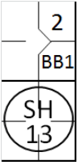 |  | /* Le premier batteur arrive sur base sur un 'base on ball' */  action { batter -> BB }  /* Le second batteur frappe un bunt , se fait retirer par le défenseur de la première base assisté par le lanceur, et fait avancer le coureur en une */  action { batter -> SH13 , runner1 -> + } |  | 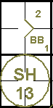

In the example 9 the sacrifice hit (bunt) to third base enables the runner to advance from second to third base. An error by the first baseman enables the batter-runner to reach first base safely.
As you can see from this example, each advance is noted with the batting order number of the player who made the sacrifice.
WBSC |  | Traduction dans l’outil de scorage |  | Outil
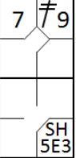 |  | /* Le premier batteur frappe un double dans le champ droit */  action { batter -> 2B9 }  /* Le second batteur frappe un but vers le défenseur de la troisième base qui récupère la balle et la relaie au défenseur de la première base pour retirer le coureur batteur, mais le défenseur relâche la balle. Le coureur en deuxième base avance */  action { batter -> SH5E3, runner2 -> + } |  | 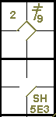

The rules states that, in order to be credited with a sacrifice hit (bunt), one or more runners must advance. In the example 10 given here only one runner advanced, but this is enough to make the hit into a sacrifice hit (bunt).
WBSC |  | Traduction dans l’outil de scorage |  | Outil
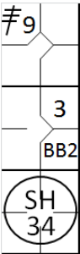 |  | /* Le premier batteur frappe un triple dans le champ droit */  action { batter -> 3B9 }  /* Le second batteur arrive sur base sur un 'base on ball' */  action { batter -> BB }  /* Le troisième batteur frappe un bunt vers le défenseur de la première base, qui récupère la balle et la renvoie au défenseur de la deuxième base pour retirer le batteur coureur. Le coureur en première base avance */  action { batter -> SH34 , runner1 -> + } |  | 

ATTENTION: Very often in a sacrifice situation the first baseman runs forward to recover the ball; in these examples it is usually the pitcher or second baseman who goes to cover first base. The scorer must take great care to record the action as it actually occurred. In the example 11 given, the second baseman went to cover first base and received the assist from the first baseman.
WBSC |  | Traduction dans l’outil de scorage |  | Outil
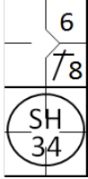 |  | /* Le premier batteur frape un hit dans le champ centre */  action { batter -> 1B8 }  /* le batteur frappe un bunt sur le défenseur de la première base qui récupère la balle qui renvoie la balle au défenseur de la deuxième base pour retirer le batteur coureur. Le coureur avance */  action { batter -> SH34 , runner1 -> + } |  | 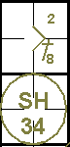

Example 12: A special case of sacrifice hits (bunts) occurs when the defense tries to put out a runner and fails, without committing any errors. In this case the batter who reaches first base must be given a sacrifice and fielder’s choice.
WBSC |  | Traduction dans l’outil de scorage |  | Outil
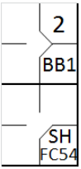 |  | /* Le premier batteur atteint la première base sur un 'base on ball' */  action { batter -> BB }  /* Le batteur frappe un bunt vers le défenseur de la troisième base qui récupère la balle et la relaie au défenseur de la deuxième base pour tenter sans sucés de retirer le coureur */  action { batter -> SHFC54 , runner1 -> + } |  | 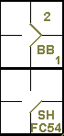
ATTENTION: When, in the scorer’s opinion, neither the batter who hit the sacrifice bunt, nor any of the runners, could have been put out by the defense with ordinary effort, a base hit (bunt) must be scored.
No sacrifice hit (bunt) is awarded if the bunt leads to a runner being put out, even if one or more runners are able to advance.
Example 13: The bunt is recovered by the pitcher, who puts out the runner going from third to home base, while the runner on first base reaches second safely. This is not a sacrifice hit (bunt) and the batter is credited with a time at bat. Add a capital B to show the bunt.
WBSC |  | Traduction dans l’outil de scorage |  | Outil
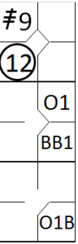 |  | /* Le premier batteur frappe un triple en champ droit */  action { batter -> 3B9 }  /* Le deuxième batteur arrive sur base sur un 'base on ball' */  action { batter -> BB }  /* Le premier batteur frappe un bunt sur le lanceur qui récupère la balle et fait le choix de relayer cette balle au receveur pour retirer le coureur qui était en troisième base */  action { batter -> O1b , runner1 -> +, runner3 -> 12 } |  | 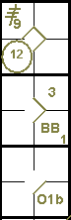
EXCEPTION: If a runner is put out trying to reach the base after the one he reached on the sacrifice hit (bunt), the batter is also awarded with a sacrifice hit (bunt).
Example 14: The runner on second base, after reaching third, continues towards home base in an attempt to exploit the error made on the batter-runner, but he is put out by the catcher with an assist from the first baseman.
WBSC |  | Traduction dans l’outil de scorage |  | Outil
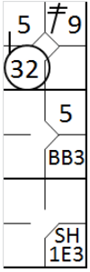 |  | /* Le premier batteur frappe un double dans le champ droit */  action { batter -> 2B9 }  /* Le deuxième batteur arrive sur base sur un 'base on ball' */  action { batter -> BB }  /* Le batteur frappe un bunt sur le lanceur qui renvoie la balle au défenseur de la première base . Le défenseur relâche la balle, et le batteur coureur arrive safe. il récupère à temps la balle  pour la renvoyer au receveur qui retire le coureur arrivant de la deuxième base */  action { batter -> SH1E3 , runner1 -> + , runner2 -> + 32 } |  | 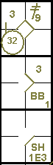
NOTE: Sometimes a batter may swing the bat with the intention of making a base hit, but succeeds only in hitting the ball softly. In this case he must not be awarded a sacrifice hit (bunt), even if one or more runners advance, as this was not the batter’s intention. The action is recorded as a normal putout on first base.

